Dear colleague
Oral Health Directorate is issuing below in response to a number of queries from dentists who are seeking clarity regarding the provision of dental treatment of patients and Covid-19.
PPE:
PCA (D) (2020) 6 – Covid-19 Guidance was issued by the CDO alongside his response letter to the Covid-19 pandemic. A further update position was released on 18th March 2020. This outlined dental procedures which are aerosol and non-aerosol generating.
A question has been raised regarding the unavoidable need to undertake an AGP on patients and the level of PPE required. The guidance states:
‘Exceptions
- Opening teeth for drainage. A high-speed handpiece would be required. The advice would be to use rubber dam which considerably reduces aerosol production along with high volume suction. The operators should wear a full-face visor and fluid-resistant mask.’

Concern has been raised that the update position from CDO does not match the general PPE guidance circulated within NHS GGC Core Brief. The brief suggests type IIR face masks are not appropriate for treating patients with an AGP.
Both guidance documents must be taken in context. NHS GGC guidance is general and is designed to cover all Board services. This does not consider the additional measures outlined in the CDO’s update, specifically the use of rubber dam and high volume suction. These additional measures are designed to reduce risk in the event an AGP on an asymptomatic patient is unavoidable.
We understand not all practices will have supplies or access to type IIR surgical masks.
For assistance, the images below depict masks commonly used in dentistry, both of which meet type IIR requirements. You may wish to check your own PPE supplies, the red highlighted wording is what identifies these as fluid resistant.
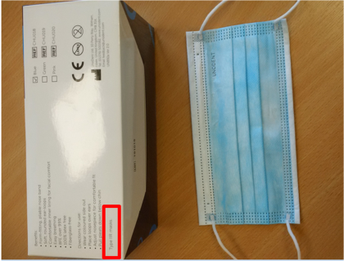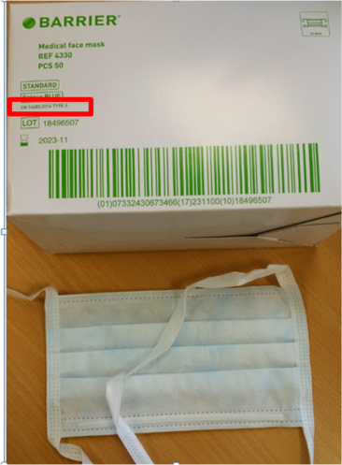
While the Board has supplies of PPE (including FFP3 masks) we have consolidated these across the directorate for use within services and this is limited.

