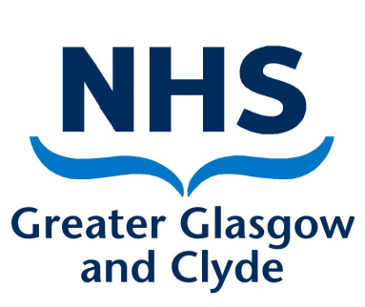
NHS Greater Glasgow & Clyde
Oral Health Directorate, Urgent Dental Centres

PDS Surgery Booking Form
In order to facilitate arrangements please email this form to ggc.publicdentalspecialcare@nhs.scot

Site requested

Date

Appointment Time

Duration of appointment

Dentist’s name and GDC registration number
Dental Nurse’s name and registration number

Dentist List number

Dental Practice contact details

What FFP3 Mask does the attending dentist require .i.e. 3M 1863 or 1863+ etc.
What FFP3 mask does the attending nurse require .i.e. 3M 1863 or 1863+ etc.

PDS Sites Available
Location | Number of surgeries available | Number of appointment slots available per day | Report to  Address | Office Contact
Bridgeton Health Centre | 2 | 2 | Dental Reception | 0141 201 5090
Vale Centre for Health and Care | 1 | 2 | Dental Reception | 01389 828 350
Royal Alexandra Hospital | 2 | 6 | Dental Reception | 0141 531 8427
Pollok Health Centre | 2 | 6 | Dental Reception | 0141 5316833

